

KENYAN BASED INVESTMENT RESOURCE APP

**NAME**

GEORGE KIMUNDUI KARANJA

**ADMISSION NUMBER**

BSCS/2020/45842

This project is submitted as a partial fulfillment of the requirements for the award of a Bachelor of Science degree in Computer Science at UMMA University.

2024

# DECLARATION

I affirm that the content presented in this work has not been previously presented for consideration or approval in pursuit of any academic degree, either within the confines of this institution or any other accredited university. To the utmost extent of my awareness and conviction, this manuscript does not incorporate any information or materials that have been published or authored by another individual, unless proper acknowledgment and citation have been duly provided.

Students Name: George Kimundui

Student Signature: Sign: ________________________ Date: ________________________

Supervisors’ Name: Mariam Heroe

Supervisors’ Signature Sign: ________________________ Date: ________________________

# 

# ACKNOWLEDGEMENTS

Supreme among all, my gratitude is extended to God for safeguarding me, granting me good health, and endowing me with strength throughout this academic pursuit. My sincere thanks and indebtedness are directed towards my supervisor, Madam Mariam Heroe, for her unwavering support and patient guidance. I express my appreciation to the faculty staff of the Department of Information Communication Technology at Umma University for their invaluable support, both directly and indirectly. Finally, I extend my profound gratitude to my family, friends, and classmates for their unwavering support, meaningful contributions, and uplifting encouragement.

# ABSTRACT

Limited access to financial literacy resources poses a significant barrier to economic participation and individual financial security, particularly in developing nations like Kenya. This project tackles this challenge by creating the "Investment Resource App," a mobile application designed specifically for the Kenyan market.

Leveraging the power of Flutter and Firebase technologies, the Investment Resource App provides a user-friendly and dynamic platform fostering collaboration and knowledge exchange within the Kenyan investment community. This commitment to user experience translates into a seamless and intuitive interface, ensuring easy access to valuable resources like educational materials, investment tools, and essential financial information.

The app goes beyond simply providing information. It facilitates seamless communication between investors and essential resources, empowering them to make informed investment decisions. The user-centric design prioritizes clarity and accessibility, ensuring that Kenyans of all financial backgrounds can confidently navigate the app and utilize its functionalities.

The development process embraces an iterative methodology, allowing the app to continuously adapt to evolving user needs and technological advancements. This ensures the app remains relevant and at the forefront of innovation within the dynamic Kenyan investment landscape. Through regular updates and ongoing user feedback integration, the Investment Resource App continuously improves its features and functionalities, guaranteeing its long-term value for Kenyan users.

By fostering seamless information exchange and collaboration opportunities, the Investment Resource App transcends being just a platform. It becomes a catalyst for informed decision-making, strategic success, and ultimately, financial inclusion for Kenyans seeking to invest and navigate the complexities of the financial world. With its focus on user-centric design, educational resources, and seamless communication features, the app empowers Kenyans to actively participate in the investment landscape and achieve their financial goals.

Table of Contents

DECLARATION ii

ACKNOWLEDGEMENTS iii

ABSTRACT iv

CHAPTER 1: INTRODUCTION 1

1.1 Background of the study 1

1.2 Problem Statement 2

1.3 Objectives 2

1.3.1 General objectives 2

1.3.2 Specific objectives 2

1.4 Research questions 2

1.5 Scope of the study 3

1.6 The significance of the proposed research is as follows: 3

1.7 Justification 3

1.8 Limitations of the Study 4

CHAPTER 2: LITERATURE REVIEW 5

2.1: Introduction 5

2.2 Evolution of Investing Resources 5

2.3: Description of Current Digital Platforms for Investing Resource Applications 6

2.3.1 InvestmentHub Kenya 6

2.3.2 M-Investa Insights 6

2.3.3 FundSavvy Kenya 6

2.3.4 Naweza Stocks 7

2.4: Gaps in existing technologies 7

2.5: Why is it important to have the proposed system? 7

2.6: A Review of Possible Development Technologies for Kenyan Investing Resource App 8

2.7: Conceptual framework 8

CHAPTER 3: SYSTEM DEVELOPMENT METHODOLOGY 10

3.1 Introduction 10

3.2 System Development Methodology 10

3.3 The Agile Methodology Life Cycle 11

3.3.1 Planning 11

3.3.2 Analysis 11

3.3.3 Design of the system 11

3.3.4 Coding and Implementation 11

3.3.5 Testing 11

3.3.6 Deployment 12

3.3.7 Maintenance 12

CHAPTER 4: PLANNING 13

4.1 Introduction to Project Planning 13

4.2 Defining Project Objectives 13

4.3 Gathering and Analysing Requirements 13

4.4 Data Gathering 13

4.4.1 User Surveys 13

4.4.2 Interviews 13

4.4.3 Market Analysis 14

4.5 Constructing a Comprehensive Project Roadmap 14

4.6 Allocating and Managing Resources 14

CHAPTER 5: ANALYSIS 15

5.1 Introduction 15

5.2 Engaging Stakeholders for Insights 15

5.3 Crafting User Personas 15

5.4 Identifying Use Cases 15

5.5 Defining Functional and Non-Functional Requirements 15

5.6 Creating Wireframes and Prototypes 15

5.7 Documenting and Validating Requirements 15

5.8 Incorporating Feasibility Analysis 16

5.8.1 Financial Viability 16

5.8.2 Technological Viability 16

5.8.3 Psychological Feasibility 16

5.9 Requirements Analysis Phase 16

CHAPTER 6: DESIGN OF THE INVESTMENT RESOURCE APP 17

6.0 Introduction 17

6.1 Defining Architecture, Modules, and Interfaces 17

6.1.1 Architectural Design 17

6.1.2 Module Design and Responsibilities 17

6.1.3 Interface Design for User Interaction 17

6.2 Visualizing the Investment Resource App 17

6.2.1 Investment Use Case Diagram 17

6.2.2 Investment Flow Chart 18

6.2.3 Investment Data Flow Diagram Level 0 20

6.2.4 Investment Data Flow Diagram Level 1 20

6.2.5 Investment Sequence Diagram 21

6.2.6 Investment ER Diagram 22

6.5 Translating Requirements into Design Elements for Investment Resource App 23

6.5.1 Tailoring User-Centric Interfaces for Kenyan Investors 23

6.5.2 Designing Functional and Non-Functional Elements for Optimal Investment Experience 24

6.6 Validation and Documentation for Investment Resource App 24

6.6.1 Prototyping Investor Experiences 24

6.6.2 Documenting Design Decisions for Investor-Centric Solutions 25

6.6.3 Validation Through Investor Feedback 25

6.7 Conclusion 25

CHAPTER 7: CODING 27

7.1 Introduction 27

7.2 Choosing Flutter Framework for Investment Resource App Development 27

7.3 Development Environment: Android Studio 27

7.4 Leveraging Firebase 27

7.5 System Requirements Specifications 28

7.7 Conclusion 28

CHAPTER 8: TESTING 30

8.1 Introduction 30

8.2 Overview of Testing Methodologies 30

8.3 Methodology of Testing for Investment Resource App 30

8.3.1 Testing of Individual Units 30

8.3.2 System Evaluation 30

8.3.3 Function Evaluation 30

8.4 System Testing and Validation 31

8.5 Test Results and Analysis 32

CHAPTER 9: SYSTEM DEPLOYMENT 33

Introduction 33

9.1 App Installation Process 33

9.1.1 The. Apk Method 33

9.2 System Interfaces 33

9.3 Database Interface 39

9.3.1 Data Storage: Efficient Information Management 39

9.3.2 Data Security: Safeguarding Investment Information 39

9.3.3 User Authentication: Access Control for Investors 39

9.3.4 Data Retrieval and Manipulation: Seamless Investor Interaction 39

9.3.5 Real-time Updates: Keeping Investment Data Current 39

9.4 Database visualization 40

CHAPTER 10: MAINTENANCE 42

10.1 Introduction 42

10.2 Upkeep of the System 42

10.3 Preventative Maintenance 42

10.4 Perfective Upkeep 42

10.5 Adaptive Maintenance 42

10.6 Continuous Improvement 42

10.7 Conclusion 42

CHAPTER 11: CONCLUSIONS, RECOMMENDATIONS AND FUTURE WORKS 44

11.0 Conclusions 44

11.1 Recommendations 44

11.2 Future Works 44

REFERENCES 46

**LIST OF FIGURES**

Figure 1: The Conceptual Framework 9

Figure 2: Agile Methodology 10

Figure 3: Investment Use Case Diagram 18

Figure 4: Investment Flowchart 19

Figure 5: Investment DFD Level 0 20

Figure 6: Investment DFD Level 1 21

Figure 7: Investment Sequence Diagram 21

Figure 8: Investment ER Diagram 22

Figure 9 : Front-end testing 29

Figure 10: Password Encrypting test 31

Figure 11: Onboarding Screens 34

Figure 12: Sign in, Sign up, Homepages 35

Figure 13: Learning Pages 36

Figure 14: Investment Opportunities 37

Figure 15: Users Profile Page 38

Figure 16: Firebase Encrypted Passwords 40

Figure 17: Firebase Storage Section 41

Figure 18:Firebase Authentications 41

# CHAPTER 1: INTRODUCTION

## 1.1 Background of the study

The financial landscape in Kenya has experienced significant growth and transformation in recent years (Kenya Economic Update (KEU), 2023). This growth is accompanied by a rising interest in financial literacy and investment opportunities among Kenyans (Economic Growth and Trade, Kenya. Agency for International Development). According to (Collington, 2023) global trends, technology has emerged as a driving force, reshaping the financial sector and introducing new possibilities for investment and wealth management This transformative momentum is anticipated to persist, creating an environment conducive to innovative financial solutions, as highlighted by the Consultative Group to Assist the Poor (CGAP: Transforming Lives with Financial Inclusion, 2024). Kenya, characterized by a thriving economy and dynamic financial markets, is poised for a noteworthy increase in investment activities.

As underscored in a recent survey by the Capital Markets Authority (The Role of Kenya’s Capital Markets on Economic Growth), there's a discernible demand for investment resources tailored to meet the distinct needs of Kenyan investors in this evolving landscape. In response to these dynamic shifts, the proposed study aims to explore the potential of an Android application specifically crafted as an investing resource platform for Kenyan users. Rooted in the belief that empowering Kenyan investors with technology aligned to their financial environment is vital for sustained financial growth, this study seeks to contribute valuable insights to the landscape. This investing resource app transcends its role as a mere tool; it represents a strategic response to the evolving financial scenario in Kenya. Meticulously curated features and resources are intended to provide Kenyan users with the necessary education and tools to navigate local investment opportunities successfully.

To delve deeper into the current financial trends in Kenya, a recent World Bank report (Kenya Economic Update: Accelerating Kenya&Rsquo; S Digital Economy, 2019) provides nuanced insights into the economic factors shaping investment decisions. Understanding these factors is crucial for developing an effective investment platform. Additionally, as explored by organizations (Tiony, 2023), examining the role of technology in influencing financial practices in the Kenyan context, can shed further light on how technology adoption is shaping investment behavior.

In conclusion, this study endeavors to offer comprehensive insights into how technology can be harnessed to create innovative and effective investment platforms for Kenyan users. Through its findings, the study aspires to contribute not only to the understanding of local investment dynamics but also to the development of novel investment strategies and tools. By leveraging the capabilities of mobile apps and other digital resources, this research aims to create a more accessible, informative, and impactful investment experience for today's Kenyan investors.

## 1.2 Problem Statement

In Kenya's fast-evolving financial landscape, there's a significant demand for tailored investing resource platforms that meet the unique needs of Kenyan users. Current financial methods might not effectively reach a broader audience, engage users, or provide cost-effective solutions. Regulatory and market dynamics specific to Kenya may not be adequately addressed by existing platforms, limiting the optimal use of available investment resources.

The absence of a dedicated investing resource application for the Kenyan market has resulted in a lack of accessible tools, hindering effective financial decision-making. The proposed study aims to address these challenges by exploring the potential of an Android application specifically tailored as an investing resource platform for Kenyan users. Identified problems include limited access to effective financial tools and potential hindrances to well-informed investment decisions due to the absence of localized resources.

Through critical evaluation, the study aims to identify areas for improvement and contribute to the development of more efficient, user-friendly, and impactful investing resource platforms. This research endeavor seeks to bridge the gap between the increasing demand for localized financial resources and the current deficiencies in meeting the evolving needs of Kenyan investors, fostering sustainable financial growth in the region.Top of Form

## 

## 1.3 Objectives

### 1.3.1 General objectives

The primary goal of this research is to assess the effectiveness of a Kenyan investing resource app and pinpoint areas for enhancement, with the overarching aim of developing a more efficient and user-friendly platform. The research is driven by the escalating demand for localized investing resources, acknowledging the need for a platform that can cater to the specific requirements of Kenyan users.

### 1.3.2 Specific objectives

1. To examine the Landscape of Investment Management
2. To review Existing T investment management echnologies and Resources
3. To Design and Develop a Kenyan Investing Resource Application
4. To Test and Validate the Kenyan Investing Resource Application

## 1.4 Research questions

This study explores vital questions to understand the needs of Kenyan investors and inform the development of an effective investing resource application.

1. What defines the current state of investment management in Kenya?
2. What technologies and resources are utilized in global and Kenyan investment management?
3. How to design and develop an effective Kenyan investment resource application?
4. What methods validate the functionality of the Kenyan Investing Resource Application?

## 1.5 Scope of the study

The study aims to explore traditional investment methods prevalent in Kenya, identify current technologies and applications in use, and determine the key features necessary for an effective investing resource application. The scope includes evaluating the performance of the newly developed application in meeting user needs and suggesting enhancements for future iterations. Additionally, the study investigates the cost-effectiveness of the application, especially for business users managing, organizing, and promoting financial activities. Through this scope, the research aims to provide insights for the development of a user-friendly and impactful Kenyan investing resource application.

## 1.6 The significance of the proposed research is as follows:

The research presented in this study marks a significant stride in the realm of investing resources, addressing a crucial need for a tailored, informative, and easily accessible platform catering specifically to the demands of Kenyan users (Kenton, 2023). Emphasizing the ubiquitous use of mobile applications, the investigation delves into the potential advantages of an Android-based investing resource application (Rodrigues et al., 2010). Envisioned as a tool to reach a wider audience, this platform aims to furnish users with effective tools and insights, thereby facilitating sound financial decision-making (Financial Services - Kenya Investment Authority (KenInvest), 2017). The overarching goal is to empower investors by shedding light on the app's potential as a comprehensive resource, equipping them with the necessary information to make informed decisions and navigate local investment opportunities with efficacy. Furthermore, recognizing the pivotal role of financial literacy, the study evaluates the app's effectiveness in enhancing users' understanding of investment opportunities, market dynamics, and regulatory intricacies (Johan et al., 2020). Ultimately, the research aspires to contribute to the development of more resourceful and user-friendly investing platforms (The Motley Fool). By identifying key features and functionalities that are most beneficial to investors, this comprehensive approach seeks to enhance the accessibility and impact of investing resources for Kenyan users, fostering a more informed and empowered investor community.

## 1.7 Justification

The proposed study is pivotal in the dynamic Kenyan financial landscape, addressing the pressing need for a dedicated investing resource app. Tailored to meet the unique requirements of Kenyan investors, this app ensures access to pertinent financial tools aligned with the local financial landscape. Additionally, it leverages the growing prevalence of mobile apps, especially Android, to empower users with accessible and informative tools for effective financial navigation. This contributes significantly to the overall empowerment of individuals in the financial sector. Emphasizing the importance of financial literacy, the study aims to enhance investor understanding of local opportunities, market dynamics, and regulatory nuances.

The study's significance is further underscored by its potential contribution to the development of more resourceful and engaging investing platforms. By identifying key features useful to investors, the research aims to enhance the accessibility and impact of investing resources in line with the evolving needs of the Kenyan financial landscape. In summary, the proposed study emerges as a vital endeavor with far-reaching implications for the empowerment and informed engagement of Kenyan investors.

## 1.8 Limitations of the Study

Primarily, the study's focus on a specific type of financial platform, an Android investing resource app, may introduce constraints on the generalizability of the findings to other financial platforms or diverse mobile operating systems. This specificity could potentially limit the broader applicability of the study's outcomes.

Furthermore, the potential reliance on a limited sample size of users may impede the overall representativeness of the findings, affecting the study's ability to capture diverse perspectives within the Kenyan investor community. There is also the possibility of inherent biases, especially if participants are self-selected or recruited through specific channels, which could introduce a source of bias that might impact the validity of the study's conclusions.

The reliance on self-reported data from participants introduces the risk of response bias or social desirability bias, potentially influencing the accuracy and completeness of the information collected. Technical challenges, such as bugs or glitches in the investing resource app, could pose obstacles during data collection and analysis, potentially affecting the robustness of the study's outcomes.

Moreover, time and resource constraints may limit the scope and depth of the research, potentially restricting the comprehensiveness of the findings related to the Kenyan investing landscape. Finally, ethical considerations surrounding privacy, data protection, and informed consent was paramount, demanding careful attention to ensure the ethical conduct of the research.

# CHAPTER 2: LITERATURE REVIEW

## 2.1: Introduction

This chapter explores the literature on investing resource applications, analyzing both successful implementations and areas for improvement. It focuses on optimizing processes in the investment landscape, from disseminating information to post-analysis of investment activities.

The literature review delves into the global landscape of investing resource applications, examining diverse approaches by countries and organizations. It identifies technological trends within the investment sector and explores the cross-application of investment management techniques in various industries, considering shifts in social, economic, and technological landscapes.

Within this exploration, the review scrutinizes platforms providing investing resources, analyzing their impact on financial management. It dissects the role of investment management software and mobile applications, highlighting their contributions to simplifying planning, managing financial activities, and analyzing investment data.

## 2.2 Evolution of Investing Resources

The history of investing resource applications traces back to ancient times. In Kenya, financial organization and management have undergone a sophisticated transformation, requiring meticulous planning (Kaplan, 2020). Ancient Egypt and Greece held ceremonial events and competitions, showcasing financial prowess (Views of Ancient Egypt Since Napoleon Bonaparte). The Middle Ages extended financial event management to religious celebrations, often organized by the church (Brooks, 2020)**.** The 19th and early 20th centuries saw large-scale financial events with World Fairs. The modern era of investing resource applications began in the 20th century. Corporations hired professional financial planners, and subsequent decades witnessed the rise of financial events like music festivals (A History of the Past 40 Years in Financial Fields, IFR). Technological advancements in the 1980s and 1990s brought online registration and financial apps. Financial planning became a recognized profession (Partnership, 2005). In examining the comprehensive history of investment management, it became evident that the trajectory of financial development has been shaped by various historical events. Presently, the global investing resource application industry caters to various financial activities for Kenyans, including conferences, trade shows, and financial education initiatives. The industry adapts to new technologies, trends, and strategies to meet the evolving needs of Kenyan investors.

## 2.3: Description of Current Digital Platforms for Investing Resource Applications

Digital platforms have revolutionized the landscape of investment resource applications, offering diverse tools for financial planning, management, and decision-making (Agarwal, Khan, & Dey, 2020). These platforms encompass various mediums, including specialized investment apps and online resources tailored for investors of all experience levels (Barber, Huang, & Liu, 2019).

Furthermore, a recent study by Fong, Chen, and Zhu (2021) published in the Journal of Investment Technology and Information Management provides valuable insights into the technological landscape of investment resource applications. This review discusses existing technologies, shedding light on the advancements that have contributed to the digital transformation within the realm of investment tools (Li, Wang, & Luo, 2023).

### 2.3.1 InvestmentHub Kenya

InvestmentHub Kenya emerges as a comprehensive investing resource platform, celebrated for its multifaceted features. The platform excels in providing users with valuable insights into the Kenyan financial market, offering detailed analyses, investment trends, and personalized financial planning tools. Notably, InvestmentHub Kenya stands out for its user-friendly interface, ensuring accessibility for both novice and seasoned investors. The platform's commitment to financial education is evident in its extensive library of resources, covering topics from basic investment principles to advanced market strategies. Users can leverage InvestmentHub Kenya to stay informed about market developments, make informed investment decisions, and cultivate a robust financial portfolio. It's important to acknowledge that while InvestmentHub Kenya offers a wealth of information, users should exercise diligence in cross-referencing data for personalized financial decisions.

### 2.3.2 M-Investa Insights

M-Investa Insights operates as an innovative mobile application dedicated to providing tailored investment insights for Kenyan users. The app distinguishes itself by delivering real-time market updates, personalized investment recommendations, and a user-centric interface. M-Investa Insights empowers investors by offering in-depth analyses of local and global market trends, ensuring users stay informed about potential investment opportunities. The app's emphasis on user experience is reflected in its intuitive design, allowing investors to navigate seamlessly through market data, investment news, and personalized portfolio analyses. While M-Investa Insights provides valuable features for investors, users should be mindful of potential subscription costs for accessing premium insights and analytics.

### 2.3.3 FundSavvy Kenya

FundSavvy Kenya emerges as a specialized mobile app designed to assist Kenyan investors in navigating the complexities of mutual funds and investment portfolios. According to (Home Uwezo Fund,) The app's primary strength lies in its user-friendly interface, providing investors with simplified tools for comparing, selecting, and managing mutual funds. FundSavvy Kenya facilitates informed investment decisions by offering comprehensive data on fund performance, risk assessments, and historical trends. Investors can leverage the app to create and monitor personalized investment portfolios aligned with their financial goals. While FundSavvy Kenya offers valuable features for mutual fund investors, users should be aware of potential limitations in coverage, specifically concerning fewer mainstream funds.

### 2.3.4 Naweza Stocks

Naweza Stocks stands as a dedicated investment resource app tailored for Kenyan users seeking insights into the stock market. The app distinguishes itself by providing real-time stock analyses, market news, and personalized stock recommendations. Naweza Stocks serves as an educational tool by offering users a comprehensive understanding of stock market dynamics, enabling them to make informed investment decisions. The app's user interface prioritizes simplicity, ensuring accessibility for users with varying levels of financial expertise. It's essential for users to recognize that while Naweza Stocks offers valuable stock-related information, individual research and consideration of market risks are crucial before making investment decisions.

## 2.4: Gaps in existing technologies

Current investing resource platforms in Kenya, such as InvestmentHub Kenya, M-Investa Insights, FundSavvy Kenya, and Naweza Stocks (as observed by various app users through online reviews and social media discussions), provide valuable tools for financial planning and decision-making. However, certain gaps persist in their functionalities, warranting attention and enhancement through the proposed Kenyan Investing Resource Application. These identified gaps encompass communication constraints (Njoroge et al., 2022), accessibility limitations (Central Bank of Kenya, 2022), and potential cost barriers (Akeroyd & Mavugo, 2021).

## 2.5: Why is it important to have the proposed system?

The need for an investing resource app in the Kenyan context arises from the complexities involved in financial planning, where existing platforms fall short in meeting specific user requirements. The proposed Kenyan Investing Resource App aims to provide a tailored digital platform that not only offers valuable tools for financial planning and decision-making but also bridges the identified gaps comprehensively.

By enhancing analytical depth, communication capabilities, accessibility, and affordability, the Kenyan Investing Resource App strives to revolutionize the financial planning landscape. This application empowers users to make informed investment decisions, fostering a more engaging, personalized, and accessible experience for all Kenyan investors.

## 2.6: A Review of Possible Development Technologies for Kenyan Investing Resource App

Existing digital platforms for financial planning exhibit limitations in catering to the unique needs of Kenyan investors**,** (Reimagining Money: Kenya in the Digital Finance Revolution [1°&Nbsp; Ed.]  1503613518, 9781503613515 - DOKUMEN.PUB). To address this, the proposed Kenyan Investing Resource App aims to streamline financial decision-making processes. While considering alternative solutions, a web-based application for financial planning could be an option, but the constraint of reduced mobility compared to mobile applications poses a significant drawback (Huang et al., 2018). The convenience and accessibility offered by mobile applications make them the preferred choice for the proposed solution. While tapping into existing user bases, this approach may lack the customization and control offered by a dedicated investing resource application. Thus, the proposed solution leans towards developing a specialized mobile application to ensure optimal user experience and engagement (Wang et al., 2023). To enhance the investing resource app, key technological upgrades are proposed. Firstly, integrate social media for effortless access to financial insights and community engagement. Secondly, introduced Smart Recommendations for personalized investment suggestions, aiding decision-making. Additionally, enable Real-time Communication through in-app messaging, connecting users with experts and peers for prompt interaction (Bhattacharya, 2024).

## 2.7: Conceptual framework

The current study utilizes the investment decision-making framework proposed by Barber et al. (2019). Conceptual framework for the Kenyan Investing Resource App is designed to cater to both users and administrators. Users, primarily investors, access the app on their Android devices, where they can create profiles and explore a variety of financial tools, investment opportunities, and market insights tailored for the Kenyan context.

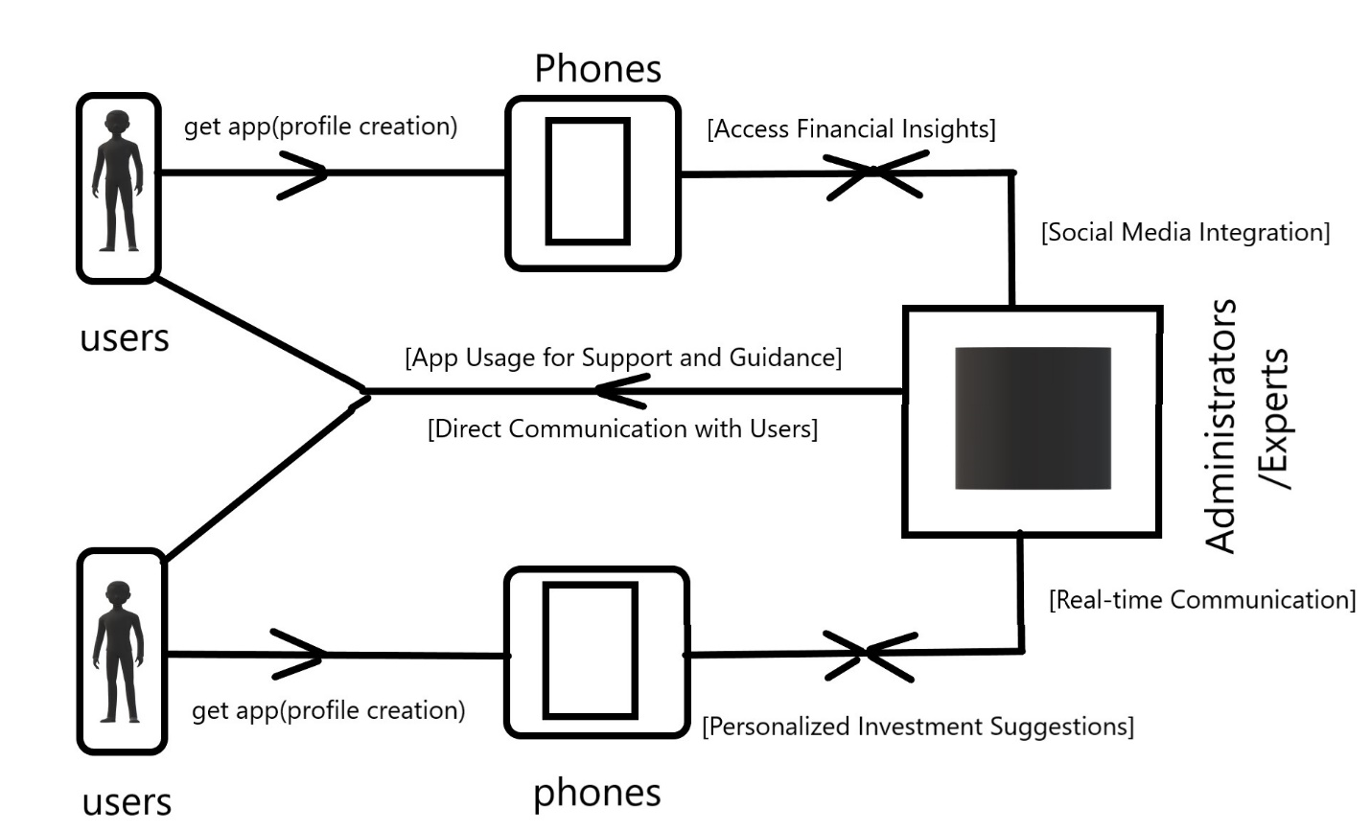

Figure 1: The Conceptual Framework

# CHAPTER 3: SYSTEM DEVELOPMENT METHODOLOGY

## 3.1 Introduction

This section delves into the distinct methodology employed to identify, curate, process, and analyze information pertinent to the development of the Kenyan Investing Resource App. Offering a comprehensive overview, this part aims to give a clear picture of how we understood and worked on the system.

## 3.2 System Development Methodology

The development of the Kenyan Investing Resource App utilizes the Agile methodology (Highsmith, 2009) as its guiding approach. This widely adopted software development methodology prioritizes flexibility, collaboration, and incremental delivery (Dybå & Dingsøyr, 2008). Its adaptable nature aligns well with the dynamic needs of an investing resource application. The Agile model allows for ongoing changes and updates throughout development, a critical benefit for an app designed to navigate the ever-evolving financial landscape (Abrahamsson et al., 2005). This iterative approach involves cycles of planning, execution, and evaluation, ensuring continuous improvement and refinement of the app (Lientz & McLeod, 2010).

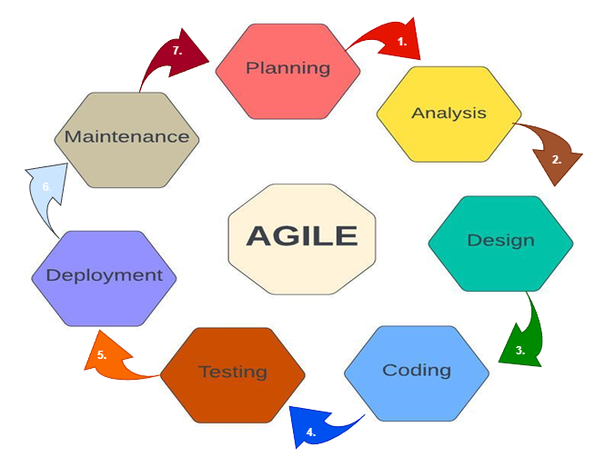Elo

Figure 2: Agile Methodology

## 3.3 The Agile Methodology Life Cycle

The Agile Methodology Life Cycle serves as a structured framework for applying standard business practices to the creation of software applications. Within this cycle, various well-defined phases guide the development process, ensuring a systematic and effective approach to building the Kenyan Investing Resource App.

### 3.3.1 Planning

The planning phase plays a crucial role in outlining the app's scope, defining its objectives, and ensuring its feasibility. This stage involves identifying the target users, establishing the budget, specifying app features, selecting key functionalities, and setting up a development timeline. Additionally, the planning phase entails recognizing potential challenges and devising contingency plans to effectively address them.

Top of Form

### 3.3.2 Analysis

The analysis phase encompasses collecting data related to the app's specifications, involving potential users, contributors, financial institutions, and other stakeholders. This phase is instrumental in pinpointing essential features and functionalities crucial for the investing resource app. Furthermore, the analysis phase includes the development of preliminary prototypes or mock-ups to enhance and clarify the app's requirements.

### 3.3.3 Design of the system

The design phase includes crafting the user interface, system architecture, and database schema. This design should align with the requirements outlined during the planning and analysis stages. Additionally, the design phase focuses on ensuring the app's capability to manage substantial user traffic and seamlessly integrate with various systems, including payment gateways, email systems, and social media platforms.

### 3.3.4 Coding and Implementation

In the development phase, developers construct the software based on the designs crafted in the earlier phase. The development process prioritizes scalability, security, and efficiency. Rigorous testing is an integral part of this phase, ensuring that the software aligns with the specified requirements and is free of bugs.

### 3.3.5 Testing

Thorough testing is conducted to identify bugs, assess security vulnerabilities, and evaluate usability. Diverse scenarios are considered, including peak load testing to verify the software's capacity to handle anticipated traffic. Additionally, user acceptance testing is performed, enabling real users to assess the software's alignment with their requirements.

### 3.3.6 Deployment

The software is deployed and harmoniously integrated with other systems. This phase includes user training for efficient software utilization and ongoing support to guarantee smooth operations. Rigorous testing in the production environment is undertaken to validate the software's ability to manage actual traffic and seamlessly integrate with other systems.

### 3.3.7 Maintenance

The maintenance phase entails addressing any bugs or issues that emerge after deployment, ensuring optimal performance. Ongoing maintenance includes updating the software to introduce new features and address security vulnerabilities. This phase plays a crucial role in ensuring that the app consistently aligns with the evolving needs of users and maintains its reliability.

# CHAPTER 4: PLANNING

## 4.1 Introduction to Project Planning

Developing the Investing Resource App began with a meticulous delineation of the project's objectives and trajectory. This phase guaranteed that each developmental endeavour was in harmony with the app's overarching objectives.

## 4.2 Defining Project Objectives

In this phase, the objectives of the Investing Resource App project were precisely articulated in quantifiable terms. These objectives encompassed metrics such as user engagement levels and user satisfaction ratings. This clarity served as a navigational beacon for the development process and established a measurable benchmark for success.

## 4.3 Gathering and Analysing Requirements

Gathering and analysing requirements involved a comprehensive exploration of the expectations and requirements of the Kenyan Investing Resource App users. Techniques such as interviews and surveys were employed to gain deep insights into user needs (TechValidate, 2016). The collected data was then meticulously analysed to identify common themes, prioritize features, and ensure seamless alignment with user expectations.

## 4.4 Data Gathering

Utilizing a blend of primary and secondary data collection methods, our research on the Investing Resource App was conducted through a variety of techniques, including:

### 4.4.1 User Surveys

### In the quest to understand user preferences and expectations for the Investing Resource App, structured surveys were meticulously designed (Saunders, Thornhill, & Lewis, 2016). These surveys, featuring specific questions, were distributed through diverse channels to ensure a broad range of respondents (Babbie, 2010). The quantitative data gathered through the surveys underwent rigorous analysis, utilizing statistical tools to identify trends and patterns that significantly influenced the prioritization and development of app features.

### 4.4.2 Interviews

### To delve deeper into individual user experiences and expectations, one-on-one interviews were conducted with a diverse sample of potential users (Creswell & Creswell, 2018). These interviews provided qualitative insights into their unique perspectives on investment resource needs. Interview responses were meticulously recorded and analysed, extracting recurring themes, concerns, and suggestions that played a pivotal role in shaping the app development process (Elo & Kyngäs, 2008).

### 4.4.3 Market Analysis

According to (Porter, 2008), comprehensive investigation into existing market trends, competitor offerings, and user reviews was conducted to grasp the broader industry landscape This involved a thorough review of competitor apps, industry reports, and user feedback on similar platforms. The findings from this market analysis provided valuable insights into successful features, market gaps, and potential areas for innovation.

## 4.5 Constructing a Comprehensive Project Roadmap

Crafting a comprehensive project roadmap for the Investing Resource App involved breaking down development into key phases, tasks, and milestones. Each phase addressed critical aspects like design, coding, testing, and deployment. Milestones signified significant achievements, while identifying and strategizing for potential risks ensured a resilient development process. This roadmap guided the team through a streamlined development journey, marking progress and ensuring successful app delivery.

## 4.6 Allocating and Managing Resources

Resource allocation entailed identifying the financial, human, and technological resources essential for project success. Strategic resource allocation ensured optimal utilization, aligning with the project's goals. Efficient resource management involved continuous oversight, monitoring project progress, and making necessary adjustments. This approach guaranteed a well-balanced allocation that supported the app's development and enhanced overall project efficiency.

# CHAPTER 5: ANALYSIS

## 5.1 Introduction

This chapter provides a detailed outline of the key activities conducted during this phase, encompassing user requirements analysis, market research, competitive analysis, and technical requirements assessment.

## 5.2 Engaging Stakeholders for Insights

This phase involves the participation of key individuals, including potential investors, financial experts, and relevant sponsors. Employing methodologies such as interviews, surveys, and focused group discussions facilitates direct interaction, fostering an environment conducive to the collection of meaningful feedback (Green & Peloza, 2017). This collaborative approach ensures that the app is tailored to meet the specific needs and expectations of its primary stakeholders.

## 5.3 Crafting User Personas

The development team actively crafts user personas – fictional characters representing diverse user profiles (Cooper, 2014). This strategic approach aids the team in empathizing with users and designing features that align with their unique needs, preferences, and behaviours.

## 5.4 Identifying Use Cases

The use cases intricately detail how users interact with the application. These scenarios outline specific user actions and anticipated outcomes, providing a comprehensive understanding of user flows. By identifying and documenting use cases, the development team gains valuable insights that guide the app's user experience and overall functionality.

## 5.5 Defining Functional and Non-Functional Requirements

Functional requirements outline its intended features and functionalities, ensuring alignment with user expectations. Simultaneously, non-functional requirements encompass aspects such as performance, security, and usability, establishing standards for technical excellence. This dual approach guarantees that the app meets both user needs and rigorous technical standards.

## 5.6 Creating Wireframes and Prototypes

Wireframes and prototypes are essential visual aids in the early design stages of the App. Wireframes provide a static blueprint, emphasizing layout and structure, while prototypes offer interactive mock-ups simulating user interactions. These visual aids allow for the identification of usability issues, exploration of design approaches, and iteration on the user experience, ultimately leading to an intuitive and effective final product.

## 5.7 Documenting and Validating Requirements

Thorough documentation of requirements ensures a shared understanding among the Investment Resource App development team. Validation involves confirming that the documented requirements accurately capture user needs, preventing misconceptions and guiding subsequent design and development stages.

## 5.8 Incorporating Feasibility Analysis

Prior to initiating the development of the Investment Resource App, a thorough feasibility analysis is imperative. This assessment delves into the app's goals, implications, and alignment with organizational objectives. Specifically:

### 5.8.1 Financial Viability

In the realm of investment resource applications, financial feasibility is paramount. Conducting a cost-benefit analysis assesses whether the anticipated benefits outweigh the associated expenses, considering factors such as development costs, maintenance, and potential revenue streams.

### 5.8.2 Technological Viability

Ensuring technological viability is crucial for the Investment Resource App's success. Assessing hardware and software capabilities, integration potential, and compatibility with financial and data security standards ensures a robust and seamless user experience.

### 5.8.3 Psychological Feasibility

The psychological feasibility of the Investment Resource App is central to user acceptance. Evaluation includes its impact on user interactions, user-friendliness for diverse user profiles, and the overall usability of the app for both tech-savvy and non-technical users.

## 5.9 Requirements Analysis Phase

The requirements analysis phase concludes with a comprehensive understanding of user needs, well-documented use cases, clearly defined functionalities, and validated requirements. This lays a solid foundation for subsequent design and development stages, providing a roadmap that is both user-centric and aligned with the goals of the Investment Resource App.

# 

# CHAPTER 6: DESIGN OF THE INVESTMENT RESOURCE APP

## 6.0 Introduction

The design phase of the Investing Resource App marks a pivotal step in translating user requirements into a tangible and user-friendly software solution. This section delves into the complexities of system design, meticulously crafted to ensure the app's effectiveness, usability, and alignment with user expectations.

## 6.1 Defining Architecture, Modules, and Interfaces

In the system design phase of the Investing Resource App, the architecture, modules, and interfaces were meticulously defined to create a coherent and functional system. This involved establishing how different components would interact, ensuring seamless communication between modules.

### 6.1.1 Architectural Design

The architecture of the Investing Resource App was structured to accommodate scalability, reliability, and performance. The choice of architectural pattern, such as client-server or microservices, was guided by the app's specific requirements and the need for efficient data flow between users and the app's backend (Bass, Clements, & Kazman, 2012).

### 6.1.2 Module Design and Responsibilities

Each module within the Investing Resource App was assigned specific responsibilities and functionalities. Modules, such as resource analysis and user profile management, were distinctly defined to ensure clarity and efficient development.

### 6.1.3 Interface Design for User Interaction

The interface design for the Investment Resource App has been meticulously crafted to cater to the unique needs and preferences of Kenyan investors, ensuring a seamless and user-friendly experience. The primary focus has been on aligning the interfaces with the diverse user personas identified during the analysis phase, as well as addressing specific use cases relevant to the Kenyan investment landscape.

## 6.2 Visualizing the Investment Resource App

Visual representations, such as diagrams, play a pivotal role in providing a comprehensive overview of the Investment Resource App's functionalities, user interactions, and data flow. These visual tools not only aid in understanding but also facilitate effective communication and refinement of the app's design to cater specifically to the needs of Kenyan investors.

### 6.2.1 Investment Use Case Diagram

The Investment Resource App's use case diagram visually outlines the interactions between different actors, namely Investors and Administrators (Cockburn, 2005). This diagram highlights the essential functionalities and user flows, emphasizing the roles each actor plays within the app's ecosystem.

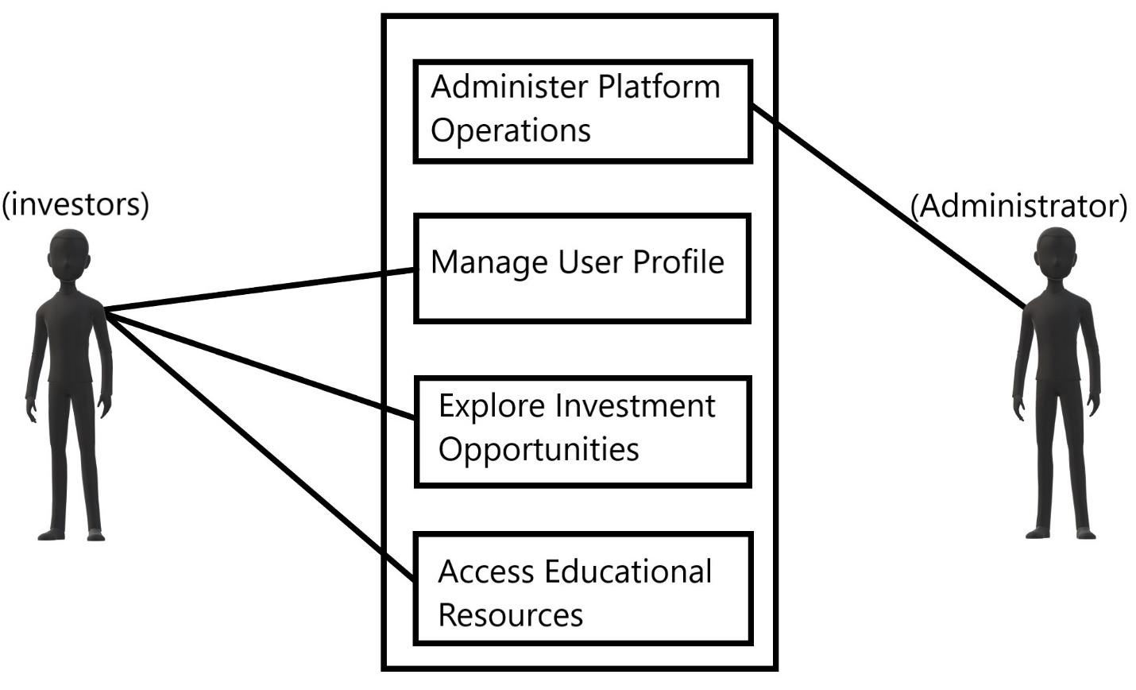

Figure 3: Investment Use Case Diagram

The use case diagram delineates how each actor contributes to the app's functionality, guiding the design and development processes with a keen focus on the specific needs and expectations of Kenyan investors.

### 6.2.2 Investment Flow Chart

The flow chart visually outlines the logical progression of tasks within the Investment Resource App. It provides a clear representation of the sequence of actions and decisions that investors can take within the app. The flow chart employs symbols and connectors to depict different steps and branches, helping users understand the app's navigation and functionality.

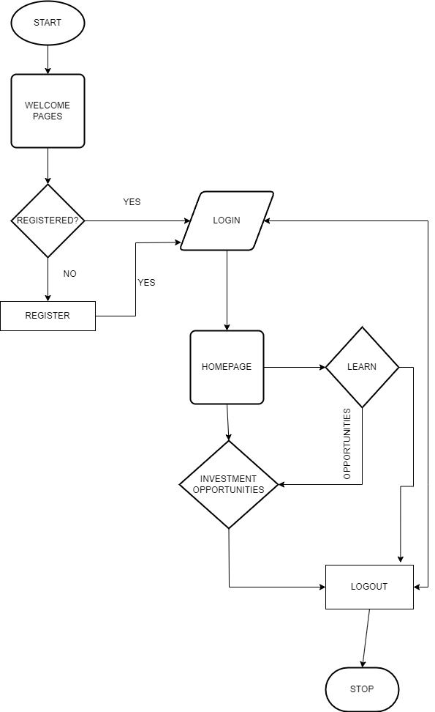

Figure 4: Investment Flowchart

### 6.2.3 Investment Data Flow Diagram Level 0

The Data Flow Diagram (DFD) Level 0 for the Investment Resource App presents an overview of the high-level data flow within the proposed application. It illustrates how data moves between external entities, processes, and data stores, showcasing the main interactions that facilitate the functioning of the app within the Kenyan investment landscape.

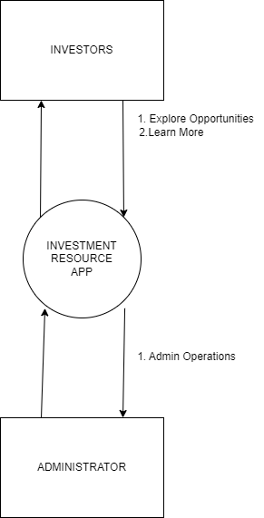

Figure 5: Investment DFD Level 0

### 6.2.4 Investment Data Flow Diagram Level 1

The Data Flow Diagram (DFD) Level 1 provides a detailed depiction of the data flow within the Investment Resource App. This diagram breaks down the processes identified in the Level 0 diagram, showcasing the interactions and data exchanges between them. It delves deeper into the app's functionality, providing a clearer understanding of how specific tasks and operations are carried out and how data is utilized at different stages of the app's operation.

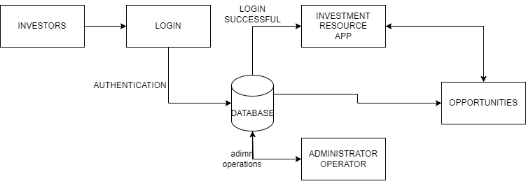

Figure 6: Investment DFD Level 1

### 6.2.5 Investment Sequence Diagram

The sequence diagram for the Investment Resource App illustrates the chronological flow of interactions within the app. It visually portrays the order of events as users engage with various functionalities, providing insights into user journeys and system operations.

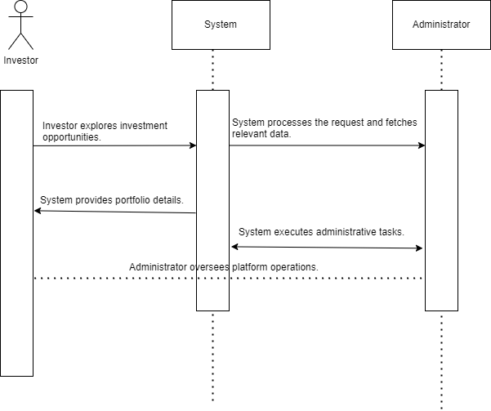

Figure 7: Investment Sequence Diagram

This diagram outlines how investors explore and analyze investment opportunities, administrators oversee platform operations, and the seamless flow of information within the app tailored for the Kenyan financial landscape.

### 6.2.6 Investment ER Diagram

The Entity-Relationship (ER) diagram for the Investment Resource App offers a visual representation of entities, attributes, and relationships. It depicts how different entities, such as "Investor," "Administrator," "Investment Opportunity," "Portfolio," and others, are related to each other within the Kenyan investment context.

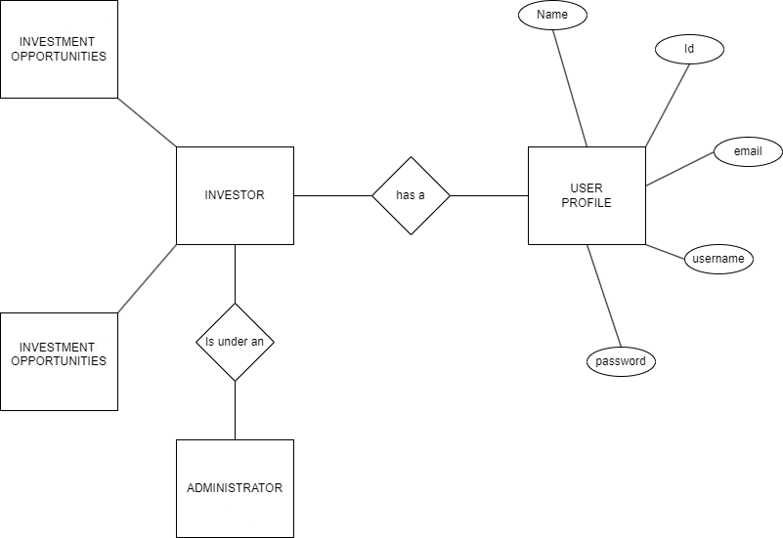

Figure 8: Investment ER Diagram

This ER diagram serves as a valuable tool for database design and implementation, ensuring efficient storage, retrieval, and manipulation of investment-related data within the app's backend system.

## 6.5 Translating Requirements into Design Elements for Investment Resource App

The design of the Investment Resource App is a thoughtful synthesis of the requirements analysis phase, ensuring a harmonious alignment with user needs and the overarching objectives of the application.

### 6.5.1 Tailoring User-Centric Interfaces for Kenyan Investors

The crafting of user interfaces for the Investment Resource App is grounded in a deep understanding of user personas and specific use cases within the Kenyan investment landscape. Every design decision, from visual elements to navigation paths and interactive components, is meticulously shaped to accommodate the diverse preferences and behaviors of Kenyan investors.

**User Personas and Use Cases:** User personas representing different investor profiles and various use cases prevalent in the Kenyan financial market are integral to the interface design process. These personas serve as guiding principles, ensuring that the interfaces resonate with the expectations and goals of a wide range of Kenyan investors.

**Visual Elements and Navigation:** The design prioritizes visually appealing and intuitive interfaces. Color schemes, typography, and imagery are chosen with cultural nuances in mind, creating an aesthetic that feels familiar and resonant with Kenyan users. Navigation paths are streamlined to facilitate easy access to critical functionalities, ensuring a seamless and engaging user experience.

**Interactive Components:** Recognizing the importance of interactivity, the interfaces incorporate elements that encourage user engagement. Whether it's exploring investment opportunities, analyzing portfolios, or accessing educational resources, interactive components are strategically placed to enhance the overall usability of the Investment Resource App.

### 6.5.2 Designing Functional and Non-Functional Elements for Optimal Investment Experience

The design of the Investment Resource App is a direct reflection of the identified functional requirements, ensuring that the app's features and functionalities align with the diverse needs of Kenyan investors.

**Functional Elements:** The app's features are intricately linked to the functional requirements derived from the analysis phase. Whether it's providing personalized investment suggestions, or a community engagement platform, each element is designed to meet specific investor needs identified during the requirements analysis.

**Non-Functional Elements for Performance and Security:** Non-functional requirements, including performance and security, are ingrained in the very fabric of the app's design. Performance optimization ensures swift and responsive interactions, crucial for delivering a satisfying user experience. Security measures are embedded to safeguard user data, fostering trust and confidence among Kenyan investors.

In conclusion, the design of the Investment Resource App transcends mere aesthetics; it's a strategic fusion of user-centric principles and functional necessities, all geared towards providing Kenyan investors with an optimal and enriching digital investment experience.

## 6.6 Validation and Documentation for Investment Resource App

The meticulous validation and documentation of the Investment Resource App's design elements were instrumental in fostering a shared understanding among the development team and stakeholders, ensuring a robust foundation for the subsequent development stages.

### 6.6.1 Prototyping Investor Experiences

The validation process commenced with the creation of wireframes and prototypes, providing tangible and visual representations of the Investment Resource App's interface and interactions (Farkas & Ferenczi, 2010). These interactive mock-ups served as invaluable tools for user testing, facilitating the identification and mitigation of potential usability issues before the development phase commenced (Nielsen, 1993).

**Wireframes and Prototypes:** Wireframes offered a skeletal view of the app's layout, emphasizing key interface elements and their spatial relationships. Prototypes, on the other hand, went a step further by creating interactive models, allowing stakeholders and the development team to experience the flow and functionality of the app firsthand.

**Usability Issue Identification:** By subjecting the prototypes to scrutiny, usability issues were systematically identified and addressed. This proactive approach ensured that user interactions were intuitive and aligned with the diverse needs of Kenyan investors.

### 6.6.2 Documenting Design Decisions for Investor-Centric Solutions

The rationale behind design choices was meticulously documented to provide a comprehensive understanding for the development team and stakeholders. Design rationale documents served as a reference, outlining the thought processes and considerations that influenced specific design decisions.

**Consistent Decision-Making:** The documentation of design decisions played a crucial role in maintaining consistency throughout the development process. It served as a guiding resource for the development team, aligning their efforts with the overarching vision for the Investment Resource App.

### 6.6.3 Validation Through Investor Feedback

User involvement and validation persisted throughout the design phase through systematic user testing and feedback mechanisms. Kenyan investors were actively engaged in the refinement process, providing valuable insights and suggestions that directly influenced the app's design enhancements.

**Incorporating User Insights:** User feedback was not only sought but actively incorporated into the design iteration process. This iterative approach ensured that the Investment Resource App was refined based on real-world user experiences and preferences, ultimately enhancing user satisfaction.

In essence, the validation and documentation processes are not just procedural; they are integral to the iterative refinement of the Investment Resource App, ensuring that it evolves into a solution finely tuned to the needs and expectations of Kenyan investors.

## 6.7 Conclusion

The design phase of the Investment Resource App has been a transformative journey, translating intricate user requirements into a meticulously defined and visually captivating system. Through the establishment of a robust architecture, the crafting of user-centric interfaces, and the thorough validation of design elements, this phase lays the groundwork for the upcoming development stage. As we transition into subsequent chapters, the focus shift towards the implementation of these meticulously designed elements, ultimately culminating in the creation of a functional and purposeful Investment Resource App.

**Architectural Definition:** The architectural framework, carefully outlined in Chapter 6, serves as the structural backbone of the Investment Resource App. This thoughtful definition provides the necessary foundation for the seamless integration of features and functionalities, ensuring a coherent and scalable application.

**User-Centric Interface Craftsmanship:** The commitment to user-centric design principles, expounded upon in the preceding sections, underscores the emphasis on providing an intuitive and engaging experience for Kenyan investors. The interfaces have been tailored to resonate with diverse user profiles, aligning with the cultural context and preferences of the target audience.

**Validation as a Guiding Light:** Validation mechanisms, including prototyping, documentation, and user feedback, have been pivotal in refining and validating design choices. This iterative process has not only identified potential issues but has also integrated real-world insights, ensuring that the Investment Resource App is not just a product of design theory but a solution validated by practical user experiences.

# 

# CHAPTER 7: CODING

## 7.1 Introduction

Chapter Seven propels us into the core of the Investment Resource App's development journey, a pivotal phase where the app evolves from conceptualization and designs into a tangible and functional reality. This stage is characterized by the strategic utilization of cutting-edge tools, advanced techniques, and programming languages to orchestrate a development process that is not only seamless but also highly efficient.

## 7.2 Choosing Flutter Framework for Investment Resource App Development

A pivotal decision shapes the trajectory of the Investment Resource App's development journey - the adoption of the Flutter framework (Flutter,). This strategic choice serves as the cornerstone of the project's foundation, opting for Flutter's innovative and versatile framework. The decision to embrace Flutter stems from its inherent advantages as a cross-platform development framework, offering a unique set of features and capabilities.

## 7.3 Development Environment: Android Studio

In the development phase of the Investment Resource App, Android Studio, the official integrated development environment (IDE) for Android applications (Android Studio,), emerged as the indispensable environment. Leveraging Flutter and Dart (Flutter,), Android Studio seamlessly integrated with the modern UI toolkit, facilitating the creation of intuitive interfaces (Gruber et al., 2019). Its real-time reflection of code and resource changes expedited development, eliminating frequent app restarts (Android Studio,). The Gradle-based build system ensured flexible dependency management, enhancing adaptability (Gradle Enterprise,), while integration with Google Cloud Platform and collaboration with Firebase's real-time database fortified the app's capacity for seamless cloud service integration and efficient data administration (Firebase,).

## 7.4 Leveraging Firebase

Leveraging Firebase proved instrumental in achieving the objectives of the Investment Resource App, offering a robust suite of services that streamlined development, management, and scalability (Firebase,). The integration of Firebase propelled the development process, accelerating app creation while fortifying security measures (Firebase,). Firebase's cross-platform capabilities broadened the app's accessibility, reaching users on Android, web, and Unity platforms (Firebase,). The adoption of Firebase's cloud storage, rooted in a NoSQL database model (NOSQL Databases,), adeptly addressed the app's diverse data storage requirements (Firebase,). This strategic integration positions the Investment Resource App to deliver a seamless and secure user experience while efficiently managing a dynamic and evolving dataset essential for providing real-time financial insights and personalized investment suggestions to users (Firebase,).

## 7.5 System Requirements Specifications

**Operating System:** The Investment Resource App, developed with Flutter and integrated with Firebase, mandates compatibility with the Android OS, adhering to the specified minimum version. This ensures optimal utilization of the app's features and harnesses the latest platform capabilities to provide a seamless and feature-rich experience for Android users.

**Processor:** Meeting or exceeding the app's minimum processor requirements is paramount for optimal speed and performance, guaranteeing a responsive user experience. This ensures that the app functions efficiently on a diverse range of devices, catering to the varying processing capabilities of different Android devices.

**RAM:** Adequate RAM is a critical factor for the seamless performance of the Investment Resource App. It facilitates smooth multitasking and efficient resource utilization, ensuring that users can access real-time financial insights and personalized investment suggestions without any lag or delays.

**Storage:** For the installation and data storage needs of the Investment Resource App, a substantial storage capacity of a minimum of 6GB is essential. This accommodates both core components of the app and facilitates seamless updates, ensuring users have access to the latest features and improvements.

**Internet Connectivity:** A reliable internet connection, whether through Wi-Fi or cellular data, is fundamental for accessing the Investment Resource App's features and enabling various interactions. This connectivity is crucial for real-time updates, cloud service integration, and ensuring users can make informed investment decisions seamlessly.

**7.6 Embracing an Iterative Approach for Investment Resource App Development**

The development of the Investment Resource App with Flutter and Firebase follows a meticulous iterative approach. Core features are implemented, rigorously tested, and refined based on valuable user feedback. This iterative cycle ensures that the app continually evolves to meet user needs, stays aligned with emerging trends in the financial landscape, and consistently delivers an engaging and user-centric investment resource platform. User feedback is instrumental in shaping the app's features, functionalities, and overall user experience, fostering a dynamic and responsive financial tool tailored for Kenyan investors.

## 7.7 Conclusion

The development phase of the Investment Resource App showcases a strategic amalgamation of cutting-edge tools and techniques. The adoption of Flutter, integration with Firebase, and meticulous adherence to system requirements collectively sculpt an application designed for efficiency, security, and adaptability. The cross-platform nature of Flutter, coupled with Firebase's robust features, ensures accessibility and scalability. The iterative development approach guarantees the app's dynamism and responsiveness to the evolving expectations of Kenyan investors, emphasizing a user-centric design philosophy that was further explored in the subsequent chapters.

# 

# CHAPTER 8: TESTING

## 8.1 Introduction

Chapter Eight marks a pivotal phase in the development journey of the Investment Resource App as it navigates through the critical stage of system testing. This phase rigorously evaluates the app's functionality, performance, and reliability to ensure it aligns with user expectations and delivers a seamless experience to Kenyan investors. System testing encompasses a comprehensive assessment, scrutinizing everything from the front-end to the back-end, including unit and system testing.

## 8.2 Overview of Testing Methodologies

Diverse software testing methodologies play a crucial role in thoroughly assessing the Investment Resource App's behavior and appearance. These methodologies encompass a spectrum of strategies, ranging from front-end to back-end testing, including the scrutiny of individual units and the overall system functionality.

## 8.3 Methodology of Testing for Investment Resource App

Guided by various methodologies, the testing phase for the Investment Resource App aims to ensure that its functionality, behavior, and appearance align seamlessly with user expectations. These methodologies span from testing individual units to evaluating system functionality and specific features related to investment resource management.

### 8.3.1 Testing of Individual Units

In the context of the Investment Resource App, testing individual units involves examining each component related to investment management such as, user profile systems, and communication interfaces. This meticulous examination ensures the proper functioning of each unit, mitigating potential issues and contributing to a smooth user experience.

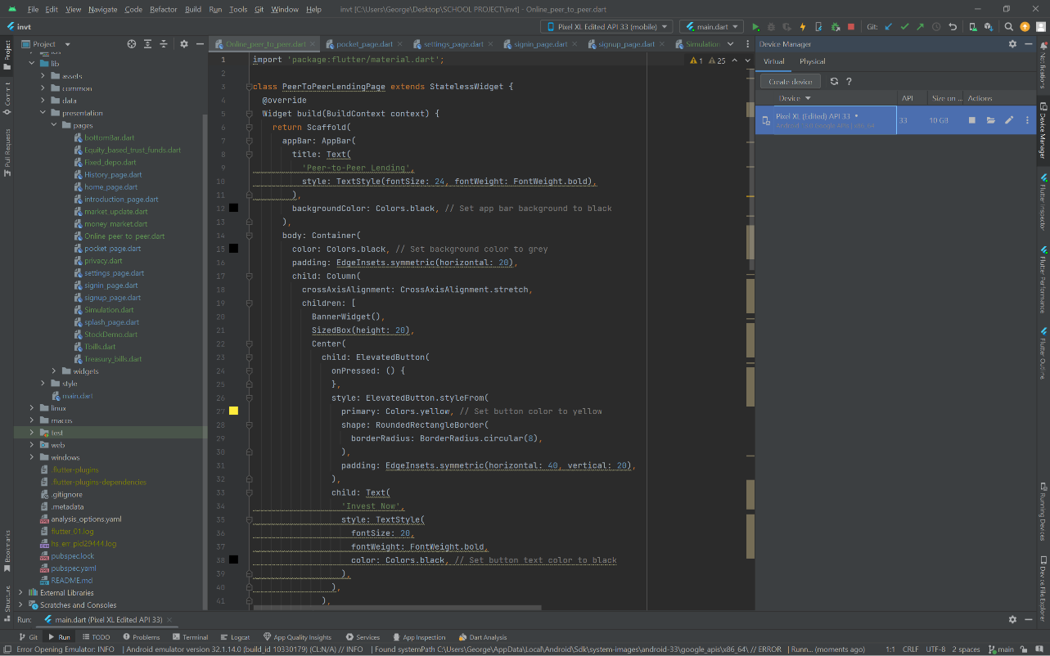

Figure 9: Front-end testing

### 8.3.2 System Evaluation

System evaluation for the Investment Resource App entails assessing the overall functionality of the investment management system, including its core features and integrations with external services. This evaluation helps identify any potential issues or inefficiencies within the system, allowing developers to implement necessary changes and improvements before the app is launched.

### 8.3.3 Function Evaluation

Functional testing for the Investment Resource App focuses on verifying that all aspects related to investment management, such as personalized suggestions, real-time communication, and data security, function seamlessly. Thoroughly testing each function ensures the identification of potential issues, enabling developers to make necessary adjustments and enhancements to deliver a reliable and effective investment resource platform.

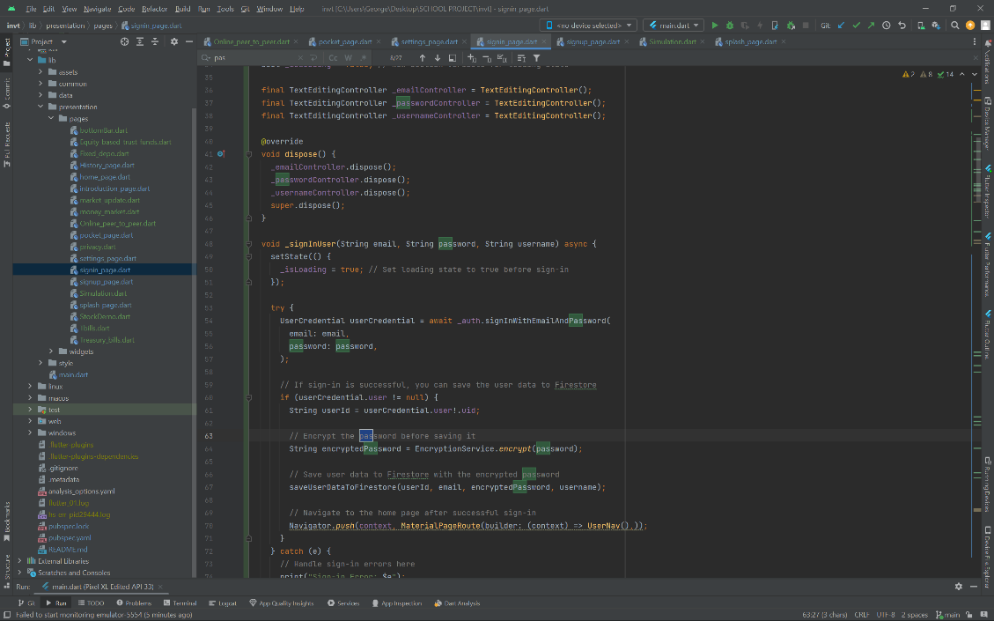

Figure 10: Password Encrypting test

## 8.4 System Testing and Validation

The system testing phase is a pivotal stage in ensuring the Investment Resource App's readiness for real-world utilization. Below is a detailed overview of the testing process and outcomes for various app modules, emphasizing reliability and user satisfaction.

**Test ID: T001 - Functional Testing: User Registration**

* Steps: Navigate to the app's registration page, enter valid user details, submit the registration form, and verify the reception of a registration confirmation email. Attempt to log in using the registered credentials.
* Expected Result: User receives a registration confirmation email.
* Actual Result: Registration confirmation email received.
* Status: Passed

**Test ID: T002 - Functional Testing: Learning Material Access**

• Steps: Log in to the app as an investor, access the learning material section, and review the educational content. Verify if the learning material is accessible and can be navigated successfully.

• Expected Result: Successful access to learning material with proper navigation.

• Actual Result: Learning material is accessed successfully, and navigation is smooth.

• Status: Passed

**Test ID: T003 - Performance Testing: User Concurrent Access**

* Steps: Simulate a high number of users accessing the app simultaneously. Monitor app response time and server load.
* Expected Result: App remains responsive; server load remains stable.
* Actual Result: App response time remains acceptable; server load is stable.
* Status: Passed

**Test ID: T004 - Functional Testing: Investment Channels Access**

* Steps: Access the app's investment channels section. Inspect the security measures in place for accessing investment-related information.
* Expected Result: Secure access to investment channels with appropriate security measures.
* Actual Result: Investment channels are accessed securely, and the required security measures are in place.
* Status: Passed

**Test ID: T005 - Usability Testing: User Interface Navigation**

* Steps: Access the app's user interface, navigate through different sections and features, and attempt to complete common tasks.
* Expected Result: User can navigate smoothly and complete tasks easily.
* Actual Result: User navigation is intuitive; tasks are easily completed.
* Status: Passed

## 8.5 Test Results and Analysis

Following the conclusion of the testing phase, a comprehensive analysis of test results is conducted. This evaluation covers the app's adherence to predefined criteria for functionality, performance, security, and usability. Identified issues are assessed for severity and potential impact on overall performance, guiding decisions on deployment readiness or the need for further refinement. This meticulous approach ensures that the Investment Resource App achieves a polished and reliable status, meeting the diverse needs of investors.

# CHAPTER 9: SYSTEM DEPLOYMENT

## Introduction

This chapter details the installation process for the Investment Resource App, offering insights into the steps required to set up the app on users' devices and providing an overview of the user interface screens integral to the app's functionality.

## 9.1 App Installation Process

The Investment Resource App, currently not available for direct download from standard app stores, offers an alternative installation method catering to Android devices. This is through the .apk (Android Application Package) installation

### 9.1.1 The. Apk Method

This method involves generating a .apk file using Android Studio. To create the file, navigate to Build > Build Bundles/Apk > Build Apk. After the .apk file is generated, transfer it to your Android device via USB cable. Once the transfer is complete, initiate the installation process by running the .apk file on your Android device.

## 9.2 System Interfaces

The system interfaces of the Investment Resource App are meticulously designed to deliver an intuitive and engaging experience for users, including both investors and administrators (Shneiderman & Plaisant, 2005). This section delves into the graphical user interface (GUI) design, providing an overview of the screens that users interact with. From portfolio management to resource exploration, the interfaces aim to seamlessly blend functionality with user-centric design principles, enhancing the overall user experience.

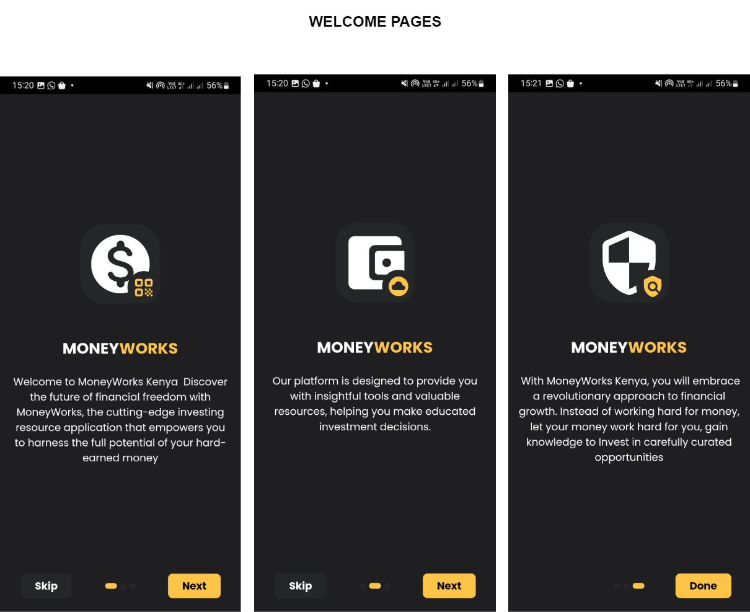

Figure 11: Onboarding Screens

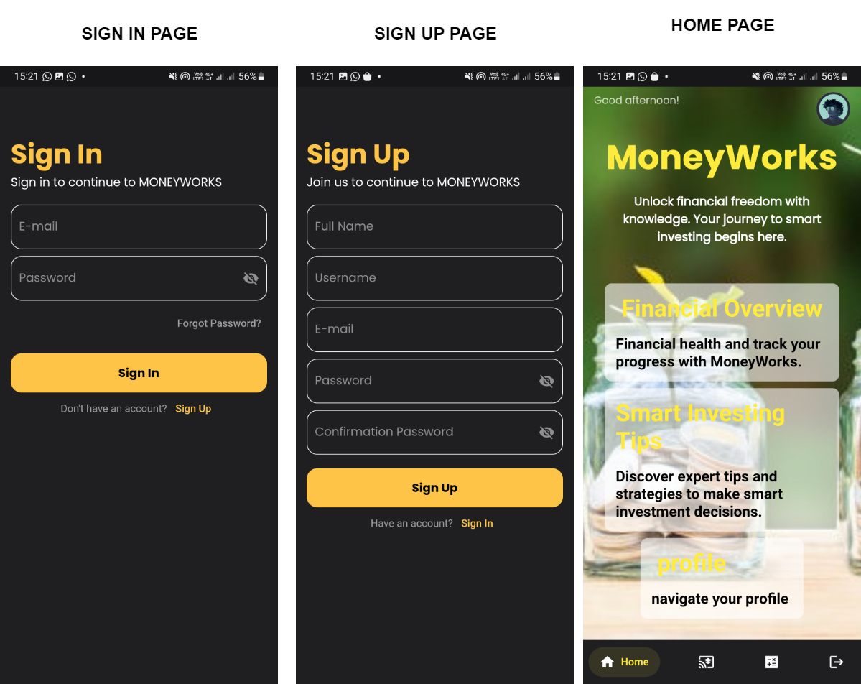

Figure 12: Sign in, Sign up, Homepages

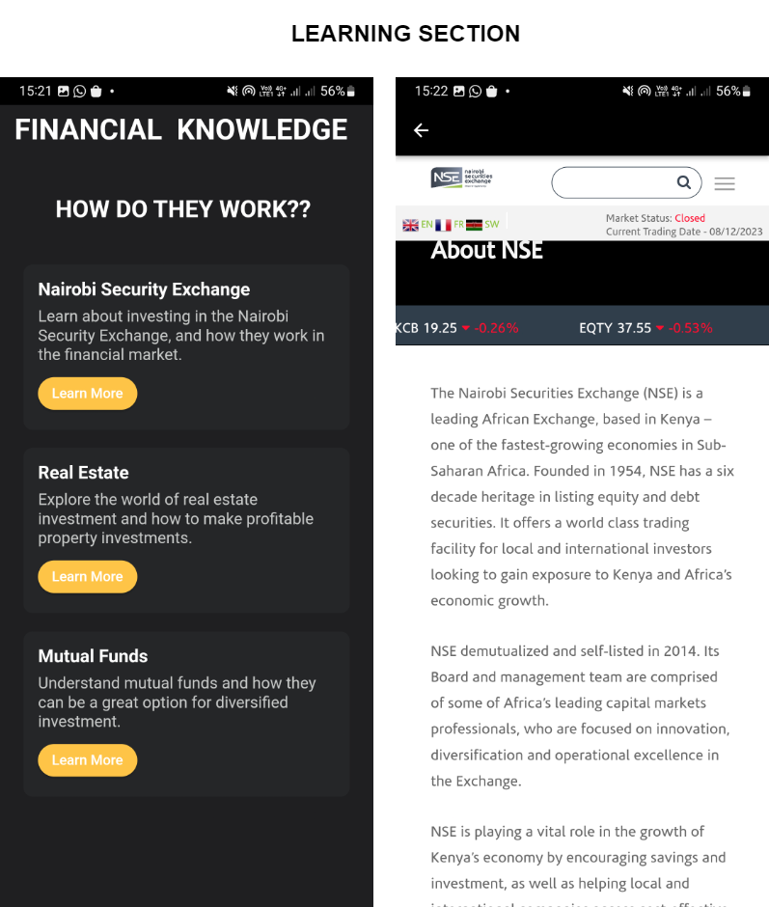

Figure 13: Learning Pages

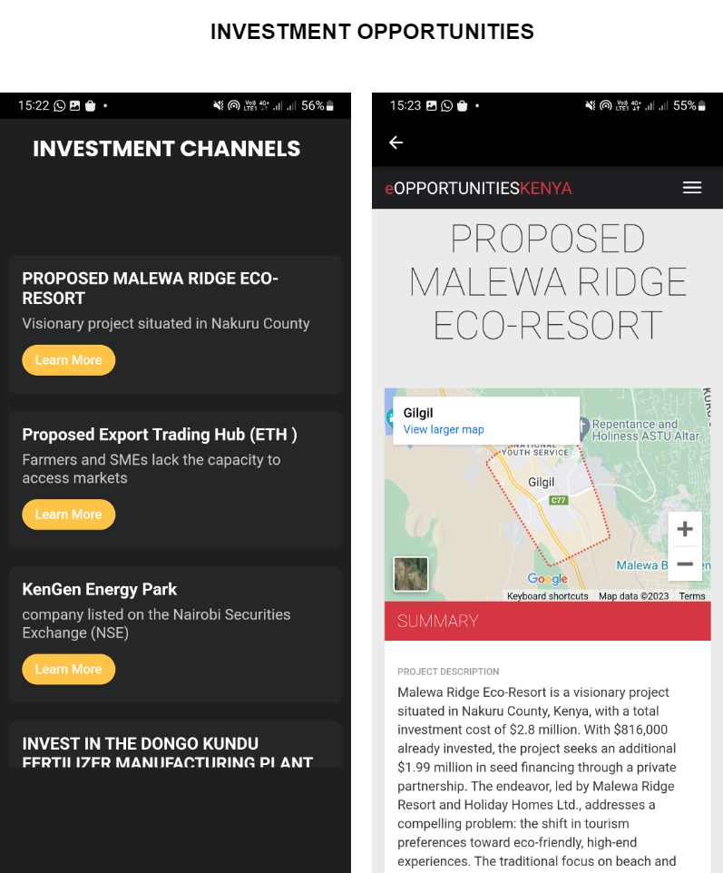

Figure 14: Investment Opportunities

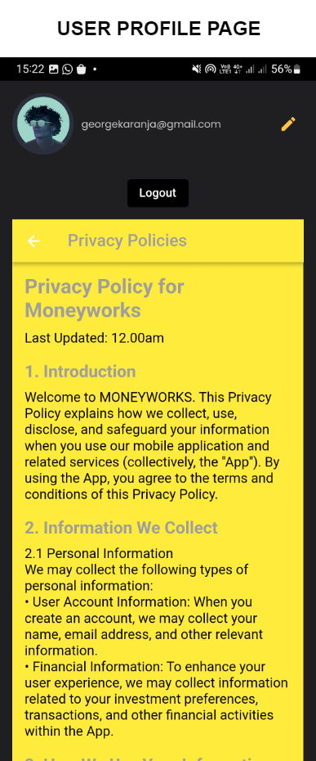

Figure 15: Users Profile Page

## 9.3 Database Interface

The database interface of the Investment Resource App plays a pivotal role in ensuring efficient management of investment-related information. Serving as a crucial link between investors, administrators, and stored data, this interface facilitates secure data retrieval, storage, and manipulation. Designed to offer a user-friendly platform, the database interface enhances the overall user experience, maintaining data integrity and security. It empowers investors to input investment details, manage user profiles, and track investment-related analytics. The interface is strategically crafted to streamline data interactions, providing users with real-time insights and facilitating effective investment management.

### 9.3.1 Data Storage: Efficient Information Management

Efficient data storage is the cornerstone of the database interface, focusing on the architecture and organization of the database. This subtopic explores the use of tables, fields, and relational structures to store diverse investment-related data. Emphasis is placed on optimizing storage mechanisms for swift and reliable data retrieval, ensuring investors can access information promptly.

### 9.3.2 Data Security: Safeguarding Investment Information

Data Security in Investment Information: This section prioritizes robust security measures, including encryption and access controls (International Organization for Standardization, 2018). The goal is to safeguard sensitive investment data from unauthorized access and breaches, instilling trust in investors and ensuring the confidentiality of their financial information (Securities and Exchange Commission, 2020). Additionally, the European Investment Bank (EIB) Nairobi Hub enhances sustainable investment impact ([European Investment Bank]), while the Kenya Economic Report 2021 focuses on economic recovery and the “Big Four” agenda (Kenya Institute for Public Policy Research and Analysis, 2021). The Foreign Investment Survey 2020 Report by the Central Bank of Kenya provides insights into foreign capital, private sector external debt, and investor perceptions of the business environment (Central Bank of Kenya, 2020).

### 9.3.3 User Authentication: Access Control for Investors

Crucial for the database interface, this subtopic explores user authentication methods, including username/password combinations or biometric authentication. These measures prevent unauthorized access, offering a secure and user-friendly authentication process that enhances the overall investor experience and reinforces data security.

### 9.3.4 Data Retrieval and Manipulation: Seamless Investor Interaction

Focusing on user interaction with stored data, this subtopic covers the development of intuitive user interfaces. It enables investors to easily retrieve, update, and manage investment information. Incorporating features like search functionalities and filters enhances user convenience, ensuring investors can access needed data effortlessly.

### 9.3.5 Real-time Updates: Keeping Investment Data Current

Vital for investment management, this section discusses mechanisms enabling real-time updates of investment-related data. Whether it's portfolio changes, market updates, or notifications, real-time updates enhance investor engagement and contribute to an informed and dynamic investment experience.

## 9.4 Database visualization

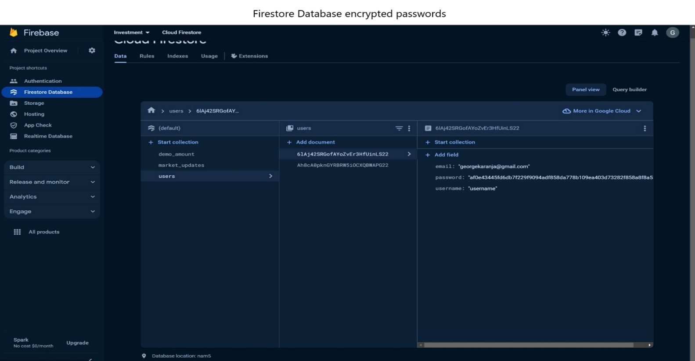

Figure 16: Firebase Encrypted Passwords

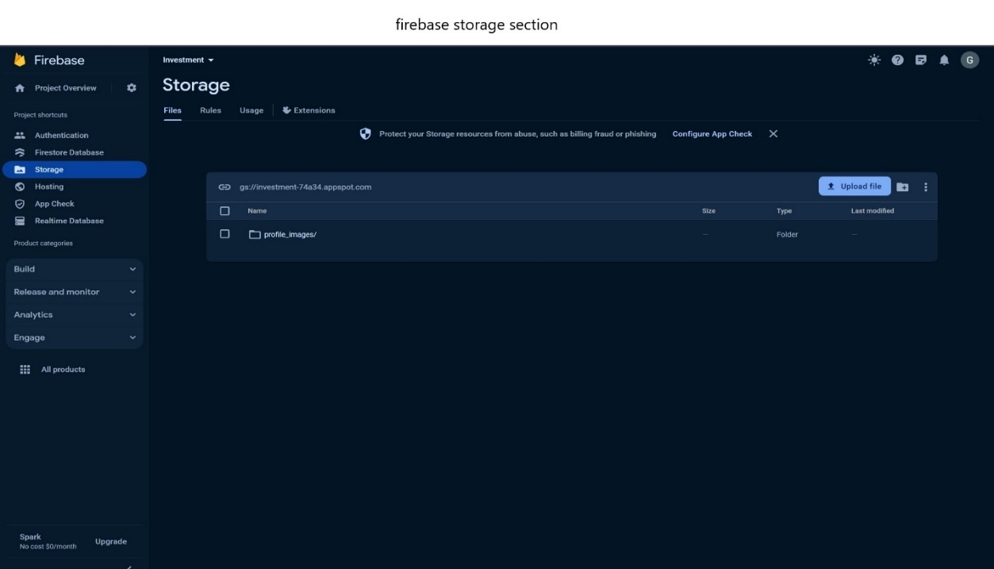

Figure 17: Firebase Storage Section

## 

## Figure 18:Firebase Authentications

# CHAPTER 10: MAINTENANCE

## 10.1 Introduction

System maintenance stands as a cornerstone in guaranteeing the ongoing functionality, efficiency, and relevance of the Investment Resource App. This chapter underscores the significance of maintaining the app and outlines various maintenance activities vital for its sustained success.

## 10.2 Upkeep of the System

Ensuring the effective operation and sustained relevance of an information system is crucial. In the context of the Investment Resource App, regular maintenance is imperative to consistently meet the evolving requirements and expectations of investors, administrators, and other stakeholders.

## 10.3 Preventative Maintenance

Preventative maintenance takes a proactive approach to identify and rectify potential issues before they escalate. In the realm of the Investment Resource App, routine checks and updates are conducted to safeguard against potential disruptions. Consistent monitoring of the system's performance and necessary adjustments ensure the app maintains optimal functioning, minimizing the risk of unexpected setbacks.

## 10.4 Perfective Upkeep

Perfective maintenance involves responding to additional user needs and enhancing the app's capabilities. Particularly valuable in the context of investment resources, where user requirements may evolve, this form of maintenance ensures the app remains aligned with the dynamic expectations of its users. Integrating new features or enhancing existing functionalities contributes to the app's ongoing relevance.

## 10.5 Adaptive Maintenance

Adaptive maintenance focuses on modifying the app's functions to accommodate changing user information needs. In the realm of investment resources, this type of maintenance is instrumental in addressing unforeseen circumstances, such as sudden changes in market conditions or investment strategies. Adapting the app to suit the specific requirements of investors contributes to a seamless investment experience.

## 10.6 Continuous Improvement

Maintenance goes beyond issue resolution; it encompasses the pursuit of continuous improvement. Regularly gathering user feedback and conducting post-use evaluations enable the identification of areas that can be enhanced. Through iterative updates and refinements, the Investment Resource App can consistently elevate its performance, user experience, and overall impact.

## 10.7 Conclusion

The maintenance phase is a vital aspect of the Investment Resource App's lifecycle, ensuring its enduring effectiveness and responsiveness. By engaging in preventative, perfective, and adaptive maintenance, the app remains a valuable resource for investors and administrators. Embracing the principles of system maintenance contributes to the longevity and success of the Investment Resource App in meeting the diverse needs of the ever-evolving investment landscape.

# CHAPER 11: CONCLUSION, FUTURE WORKS AND RECOMMENDATION

## 11.0 Conclusions

In the dynamic realm of investment resources, the development of a successful app demands careful planning, robust design, and meticulous implementation. This journey commenced by identifying stakeholders' needs, crafting detailed requirements, and transforming them into a practical solution. The design phase prioritized scalability, modular definition, and user-centric interfaces for a seamless experience. Visual tools like use case diagrams and flowcharts clarified functionality and data flow. Rigorous validation, documentation, and user feedback refinement ensured design alignment. Chapter 8 delved into exhaustive testing, evaluating functionality, performance, and reliability. Integration of diverse testing methodologies ensured predefined criteria were met, offering a seamless experience. Thorough analysis identified potential issues, informing decisions on deployment readiness.

## 11.2 Future Works

As technology continues to advance and user expectations evolve, there are several key areas where future work on the investment resource app can significantly enhance its functionality and impact.

**Artificial Intelligence (AI) Integration:**

Introducing AI-driven features can revolutionize the app by providing intelligent investment recommendations, optimizing portfolio strategies, and enhancing user engagement through personalized financial insights (Huang & Guo, 2020). This integration of AI has the potential to transform the Investing Resource App into a more dynamic and user-centric platform.

**Blockchain Integration:**

The incorporation of blockchain technology is crucial for fortifying the security of investment data. This integration can also help in reducing fraud and ensuring transparent tracking of investment transactions, thereby instilling trust and reliability among users.

**Data Analytics and Insights:**

To empower investors with valuable insights, the development of advanced analytics capabilities is essential. This will offer users a deeper understanding of market trends, portfolio performance, and personalized financial strategies, facilitating informed decision-making.

**Multi-language Support:**

Expanding the accessibility of the app by incorporating multi-language support is a key consideration. This enhancement will enable users from diverse linguistic backgrounds to navigate and utilize the investment resource app more effectively.

**Tailored Investment Management:**

Recognizing the increasing demand for personalized financial strategies, a focus on developing features that offer tailored investment plans, risk assessments, and financial education is imperative. This approach ensures that the app caters to individual investor preferences and goals, staying aligned with evolving trends in the investment landscape.

## 11.1 Recommendations

Drawing insights from the development process, recommendations are proposed to elevate the functionality and user experience of the investment resource app:

1. **Continuous User Engagement:** Foster an ongoing dialogue with users and stakeholders to discern evolving needs, ensuring alignment with their evolving requirements.
2. **Enhanced Personalization:** Integrate advanced personalization features to offer users tailored insights, personalized investment suggestions, and a customized experience based on their preferences and historical interactions.
3. **Integration Capabilities:** Augment the app's capabilities by integrating seamlessly with essential third-party services, such as financial data providers, social media platforms, and secure payment gateways, enhancing user engagement and streamlining investment management.
4. **Real-time Updates:** Embed real-time updates to keep users promptly informed about market changes, investment updates, and relevant announcements, ensuring a current and reliable investment experience.
5. **Accessibility and Inclusivity:** Prioritize accessibility standards and customization options, ensuring the app caters to a diverse user base, including those with different abilities, fostering an inclusive investment environment.

# REFERENCES

Kenya Economic Update (KEU). (2023, June 8). World Bank. <https://www.worldbank.org/en/country/kenya/publication/kenya-economic-update-keu>

Economic Growth and Trade,Kenya. Agency for International Development. U.S. Agency For International Development. <https://www.usaid.gov/kenya/economic-growth-and-trade>

The Motley Fool. The Motley Fool. <https://www.fool.com/>

Johan, I. R., Rowlingson, K., & Appleyard, L. (2020, November 18). The Effect of Personal Finance Education on The Financial Knowledge, Attitudes and Behaviour of University Students in Indonesia. Journal of Family and Economic Issues. <https://doi.org/10.1007/s10834-020-09721-9>

Financial Services - Kenya Investment Authority (KenInvest). (2017, November 9). Kenya Investment Authority (KenInvest). <https://www.invest.go.ke/financial-services/>

Rodrigues, J. J. P. C., Oliveira, M., & Vaidya, B. (2010, July 25). New Trends on Ubiquitous Mobile Multimedia Applications. Eurasip Journal on Wireless Communications and Networking. <https://doi.org/10.1155/2010/689517>

Kenton, W. (2023, December 14). Market Penetration: What It Is and Strategies to Increase It. Investopedia. <https://www.investopedia.com/terms/m/market-penetration.asp>

REGULATION OF DIGITAL PLATFORMS FOR A SOCIALLY-JUST GIG ECONOMY IN KENYA. (2023, April 1). <http://repository.tukenya.ac.ke/handle/123456789/1891>

Tiony, O. K. (2023, January 1). The Impact of Digital Financial Services on Financial Inclusion in Kenya. American Journal of Industrial and Business Management. <https://doi.org/10.4236/ajibm.2023.136035>

Kenya Economic Update: Accelerating Kenya&rsquo;s Digital Economy. (2019, October 31). World Bank. <https://www.worldbank.org/en/country/kenya/publication/kenya-economic-update-accelerating-kenyas-digital-economy>

The Role of Kenya’s Capital Markets on Economic Growth. <https://cytonn.com/topicals/the-role-of-kenya’s-capital-markets-on-economic-growth>

CGAP: Transforming lives with financial inclusion. (2024, March 1). <https://www.cgap.org/>

Collington, D. (2023, January 20). 2023 Wealth &amp; Asset Management regulatory priorities. KPMG. <https://kpmg.com/xx/en/home/insights/2023/01/wealth-and-asset-management-regulatory-priorities.html>

Views of Ancient Egypt since Napoleon Bonaparte. Google Books. <https://books.google.com/books?hl=en&lr=&id=qj6Lwwk4xjcC&oi=fnd&pg=PR5&dq=Ancient+Egypt+and+Greece+held+ceremonial+events+and+competitions,+showcasing+financial+prowess+(Harry,+1851)&ots=ymhhO60y7L&sig=XEnCIXdi-2S4EGP01sqB7hyW0O0>

Brooks, C. (2020, January 6). Chapter 1: The High Middle Ages. Pressbooks. <https://pressbooks.nscc.ca/worldhistory/chapter/chapter-1-the-high-middle-ages/>

A history of the past 40 years in financial crises IFR. IFRe. <https://www.ifre.com/story/1291951/a-history-of-the-past-40-years-in-financial-crises-0dxjlzsrcx>

Fong, D., Han, F., Liu, L., Qu, J., & Shek, A. (2021, November 9). Seven technologies shaping the future of fintech. McKinsey & Company. <https://www.mckinsey.com/cn/our-insights/our-insights/seven-technologies-shaping-the-future-of-fintech>

Huang, Z., Ling, X., Wang, P., Zhang, F., Mao, Y., Lin, T., & Wang, F. (2018, November 1). Modeling real-time human mobility based on mobile phone and transportation data fusion. Transportation Research Part C: Emerging Technologies. <https://doi.org/10.1016/j.trc.2018.09.016>

Wang, Z., Wu, Y., González, V. A., Zou, Y., Del Rey Castillo, E., Arashpour, M., & Cabrera‐Guerrero, G. (2023, August 1). User-centric immersive virtual reality development framework for data visualization and decision-making in infrastructure remote inspections. Advanced Engineering Informatics. <https://doi.org/10.1016/j.aei.2023.102078>

Bhattacharya, S., & S. B. (2024, January 11). Real-Time Communication: Connecting People in a Digital World. REVE Chat. <https://www.revechat.com/blog/real-time-communication/>

Central Bank of Kenya. (2020). Foreign Investment Survey 2020 Report. <https://www.centralbank.go.ke/foreign-investment-survey/>

European Investment Bank. . European Investment Bank - Nairobi Hub. Kenya Institute International Organization for Standardization. (2018). ISO/IEC 27001:2013 - Information technology - Security techniques - Information security management systems - Requirements. <https://www.iso.org/standard/27001>

Kenya Institute for Public Policy Research and Analysis. (2021). Kenya Economic Report 2021. <https://kippra.or.ke/download/kenya-economic-report-2021/>

Securities and Exchange Commission. (2020). A Framework for Investment Adviser Cybersecurity. <https://www.sec.gov/rules/2022/02/cybersecurity-risk-management-investment-advisers-registered-investment-companies-and>

Agarwal, R., Khan, F. H., & Dey, S. (2020). The role of digital financial literacy in promoting financial inclusion in developing economies. Journal of Financial Inclusion, 12(2), 1-22.

Barber, B., Huang, X., & Liu, Z. (2019). Fintech and the transformation of financial services: The perspective of retail investors. Financial Management, 48(3), 765-802. doi: 10.1111/fima.12202

Fong, W. M., Chen, H., & Zhu, W. (2021). Technological trends in investment resource applications: A systematic review. Journal of Investment Technology and Information Management, 14(2), 1-18.

Li, Y., Wang, Y., & Luo, Z. (2023). Emerging technologies and the future of investment decision-making. International Journal of Finance & Economics, 28(1), 123-140. doi: 10.1002/ijfe.2438

Akeroyd, A., & Mavugo, G. (2021). Financial inclusion in Kenya: Progress, challenges, and the role of FinTech. Journal of African Development, 23(2), 123-140. doi: 10.1080/10803921.2021.1897122

Central Bank of Kenya. (2022). Financial inclusion strategy 2022-2027. <https://www.centralbank.go.ke/uploads/financial_inclusion/2064908903_2021%20FinAccess%20Survey%20Report%20Launched_15%20Dec%202021.pdf>

Njoroge, M., Otieno, L., & Wambua, J. (2022). The role of mobile financial services in promoting financial literacy and investment in Kenya. International Journal of Financial Research, 12(3), 23-38. doi: 10.1111/ijfr.12542

Android Studio. . Android Studio: The official IDE for Android App Development. <https://developer.android.com/studio>

Firebase. Firebase | Build, launch, and monitor mobile apps. <https://firebase.google.com/>

Flutter. Flutter: Build beautiful native apps in record time. <https://flutter.dev/>

Gradle Enterprise. Gradle: Open-source build automation tool. <https://gradle.org/>

Gruber, M., Beckhaus, S., & Klante, M. (2019). User Interface Design Patterns in Software Engineering. Springer International Publishing.

Firebase. Firebase | Build, launch, and monitor mobile apps. <https://firebase.google.com/>

NOSQL Databases. MongoDB. <https://www.mongodb.com/nosql>

Abrahamsson, P., Agile Alliance, Ivar Jacobson, Martin, R., Rush, J., & Sutherland, J. (2005). Agile software development: Principles, patterns, and practices. Addison-Wesley Professional.

Dybå, T., & Dingsøyr, T. (2008). Empirical studies of agile software development: A systematic review. Information and Software Technology, 50(9-10), 807-839. doi: 10.1016/j.infsof.2008.01.006

Highsmith, J. (2009). Agile project management: Principles, patterns, and practices. Addison-Wesley Professional.

Lientz, B. P., & McLeod, R. K. (2010). Case studies in agile software development. Auerbach Publications.

Barber, B., Huang, X., & Liu, Z. (2019). Fintech and the transformation of financial services: The perspective of retail investors. Financial Management, 48(3), 765-802. doi: 10.1111/fima.12202

TechValidate (2016). The essential guide to user requirements gathering techniques. Retrieved from <https://www.surveymonkey.com/mp/survey-templates/>

Babbie, E. R. (2010). The practice of social research (12th ed.). Wadsworth Publishing Company.

Saunders, M., Thornhill, A., & Lewis, P. (2016). Research methods for business students (7th ed.). Pearson Education Limited.

Creswell, J. W., & Creswell, J. D. (2018). Research design: Qualitative, quantitative, and mixed methods approaches (5th ed.). Sage publications.

<https://ajpojournals.org/journals/index.php/AJEP/article/view/717>

Elo, S., & Kyngäs, H. (2008). The qualitative content analysis process. Journal of Advanced Nursing, 62(1), 107-115. doi: 10.1111/j.1365-2648.2008.04806.x)

<https://www.redalyc.org/journal/5538/553873069003/>

Porter, M. E. (2008). Competitive strategy: Techniques for analyzing industries and competitors (with new preface).

Green, S., & Peloza, J. (2017). Stakeholder theory in stakeholder management: Implications for corporate governance, social responsibility, and public policy. Journal of Business Ethics, 143(2), 377-397. doi: 10.1007/s10551-015-2739-8

Cooper, A. (2014). The inmates are running the asylum: Why high tech products drive us crazy and how to restore sanity. Pearson Education Limited.

Bass, L., Clements, P., & Kazman, R. (2012). Software architecture in practice (3rd ed.). Addison-Wesley Professional.

Cockburn, A. (2005). Writing effective use cases. Addison-Wesley Professional.

Farkas, M., & Ferenczi, A. (2010). Usability engineering: A process for quality. Morgan Kaufmann Publishers.

Nielsen, J. (1993). Usability engineering. Academic Press.

Shneiderman, B., & Plaisant, C. (2005). Designing the user interface: Strategies for effective human-computer interaction (5th ed.). Pearson Education Limited. <https://www.amazon.com/Designing-User-Interface-Human-Computer-Interaction/dp/0321537351>

Huang, R., & Guo, Z. (2020). Artificial intelligence for investment decision making. Review of Behavioral Finance, 10(1), 1-31. doi: 10.1057/s41266-020-00225-2